Representing Artificial Personalities

Greg Pisanich Michelle Prevost
Avatronics Alias | Wavefront, Inc.
San Jose, CA Mountain View, CA
gp@garlic.com prevost@sgi.com

Introduction

Hollywood and game developers are beginning to move toward the use of increasingly sophisticated digital characters in their productions. Digital “extras” were used in crowd scenes in the recent Disney animated feature Hunchback of Notre Dame, and digital animals that have very interesting behaviors have been demonstrated in games such as Creatures and Fin Fin on Teo, the Magic Planet. At a recent ACM conference on Autonomous Agents one of the invited speakers listed digital actors and a computational model of emotion as two important technologies needed to push the development of new entertainment development.

We have been working to develop lifelike digital characters whose emotion, motivations, and personality can be defined using computational models derived from basic research in the sciences. We are currently developing a methodology for evaluating the performance and behavior of the characters created using varying modeling strategies. This paper provides a brief review of our work and introduces the basis for our evaluation methodology.

Previous Work

In an earlier paper (Pisanich & Prevost, 1996), we investigated and discussed how human characteristics such as emotion, motivation, and personality might be used to form the basis for digital characters in interactive games. We did a literature review of game and university research in this are and found that there is a lot of interest and work being done in this area. Recent conferences also confirm this (Johnson, 1997).

We then dug deeper into basic and research into human behavior (emotion, motivation, and cognition). At a high level, computational models in this area describe motivations as the goals that the individual is working toward, emotions as the measure of how well those goals are being achieved, and decision making as selection mechanism to choose activities to maximize an emotional state. Although this process can at first cut be thought of as linear, many interconnections and feedback loops are implied by the literature (emotions can color decision making, emotions and motivations may interact). Also implied or used in these models are multi-levels of structure within each behavior area (as in basic, implicit, and explicit motivations, or different emotional levels).

We also looked at brain research studies that provided a multi-level perspective to the varied levels that we observed in emotion and motivation. This body of work pointed to a three-level coding structure of instinctive, emotional, and cognitive behavior.

Finally, we looked at personality theory, which is a way to describe how an individual’s response is based not only on the stimuli, but also on the individual’s nature and life experiences. Using a popular personality profile as an example, we discussed how a person’s personality might be represented a set of functions that would provide individual differences to the same emotions, motivations and decisions made.

Based on these investigations, we described a preliminary model and high level architecture for a digital character and discussed potential performance and interface considerations associated with game design. At the 1996 conference presentation, we demonstrated a partial implementation of this model, created using a commercial game development tool. This game-like environment showed simple animal-like characters interacting through primitive behaviors.

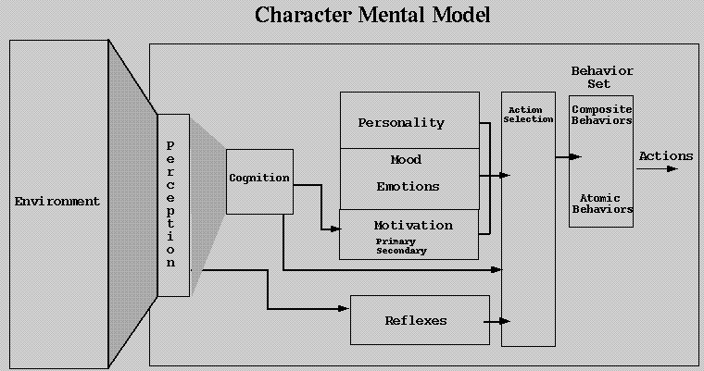

Figure 1. A prototype character architecture.

Problem

We are currently experimenting with several models and architectures for the implementation of digital characters. The models quickly get complex, with lots of interactions and subjective settings of values within “black box”-like systems. Because the values we program these systems with are subjective, we often get different output than we expect. We also know from our research that personality is a difficult thing to characterize, because it is subject to the interpretations of the viewer. The shy introvert that a content developer has created may come across as a stuck-up snob while in the senior prom scene.

We are also interested in developing character models that exhibit “emergent” behavior or personalities (Coulson et. al. 1987). These behaviors stem from the interactions of the various systems in the architecture and may not be explicitly programmed into the character. Although these behaviors may be unpredictable and difficult to control, they may be the features that give our characters human-like qualities. However, since we may not be able to foresee how and in what situations these characters may be used, many emergent qualities may be difficult to test completely and may not manifest themselves in years of gameplay.

As we as we continue to work in this area, our questions become: how do we evaluate competing models and how they manifest themselves to users? And more importantly, how will we know when we are successful at generating the character that we need?

Observing Behavior

As is our practice, we turn to science. In 1986 Susan Walton wrote an article titled “How to Watch Monkeys” about the noted Biologist Jeanne Altman and the techniques she used to watch and characterize animal behavior in Africa. Originally schooled as a mathematician, Jeanne broke away from the conventional wisdom of the time by suggesting the use of standardized methods of recording and comparing behavior. Jeanne’s methods are now the norm in this field. In addition to Jeanne’s methods, this article describes several ways of observing behavior which may be useful towards our problem.

Ad Libitum

The typical method used prior to Altman’s work was called Ad libitum sampling, which in Latin means ‘at one’s pleasure”. In Ad libitum, the observer records as much as they can of whatever catches their attention. Since a sample of behavior should be representative of the whole, then it is essential that the observer focus on behaviors and subjects that are important to the research.

However, in primate research prior to Altman’s work, researchers tended to focus where ever the action was, which tended to be on the dominant or alpha male in the group. Since male behavior tended to be the most interesting (filled with aggression and mating rituals), most early studies reported that the males’ behavior was the critical factor in most interactions.

Altman showed that if you were studying aggression in male baboons then this was OK, but if you were looking at aggression in all baboons, then you needed to make sure that you sampled baboons of both sexes and different ages. She showed that female baboons do show aggression, but it is in different ways than the males. Altman still uses Ad libitum sampling, but she believes that it is useful to get an initial sense of the animal.

Altman’s Methods

Jeanne Altman’s philosophy of observation is that it is better to focus than to generalize, recording all the behavior of a few animals than trying to record all the behavior of all the animals. Altman uses three main methods in her observations. The first is called focal sampling, which concentrates the observer’s attention on one or two animals and provides a continuous record of behavior. The second method is called scan, or instantaneous sampling, because the observer makes short “snapshot” observations at specified intervals. The third method is used to focus on a specific behavior, where the observer records all examples of feeding or behavior. In all cases, which animals are sampled depends on the research question.

Applying Altman’s methodology allowed researchers coming back from the field to compare data by controlling for sampling error and observer bias. For the first time they could compare behaviors across species and could observe at different levels of data gathering.

One-Zero

A third methodology described in the paper is called one-zero. What would be called the “binary” method by a game developer, one-zero requires a researcher to note whether a given behavior does or does not occur during a specified period, but not how often or for how long.

Altman disagrees with the use of this method, implying that frequency and duration are the basic measure of behavior. Some researchers disagree, indicating that certain research may hinge only on whether an act happened in a period of time, not how often. Altman continues to disagree, showing that a researcher can extract one-zero information from a frequency and distribution data set, but that the reverse is not true.

Animal Observations

Worth noting here is the type of observations that a zoologist or biologist might make. Their observations are critical to as the animal’s behavior is often the only indication of what is going on inside. Zoologists are trained to be objective and not to anthropomorphize the behaviors that they see.

Some of the behaviors biologist look for include how species members interrelate or cluster (such as flocking, solitary pairs, harem or matriarchy). They also look at survival techniques such as escape, mating, and securing resources such as nesting sites or food. They also focus on conflict behaviors, displays, and methods of communication to learn more about the species or member under observation. It will be important to review the anthropology literature and develop a similar list for digital human behavior.

Experiment

We are currently implementing character models in Java using a subset of the architecture shown above. We have created several simple animal characters and have imbued them with differing behaviors and personalities and plan to place them in changing environments. We are testing the use of the Altman observation methodology as a way of objectively recording our reactions to (or understanding of) these creatures. The results should give us a better measure of how well our models and characterizations match those that we are trying to create.

Bibliography

Coulson, R., Folse, J., Loh, D. (July 17, 1987). Artificial intelligence and Natural Resource Management, Science, 262-267.

Johnson, W. L. editor (1997). Proceedings of the First International Conference on Autonomous Agents, ACM: NY, NY.

Pisanich, G. & Prevost, M. (1996). Representing human characters in interactive games. Proceedings of the Computer Game Developers Conference, (pp. 377-388). San Francisco: Miller-Freeman, Inc.

Reiter, C. (June, 1986). Toy universes. Science 86, 55-59.

Walton, S. (June, 1986). How to watch monkeys. Science 86, 22-27.

